Workshop for Chapter 6: Empirical Model Identification

Textbook end-of-chapter Question 6.4 (restrict your answer to the Process Reaction Curve)

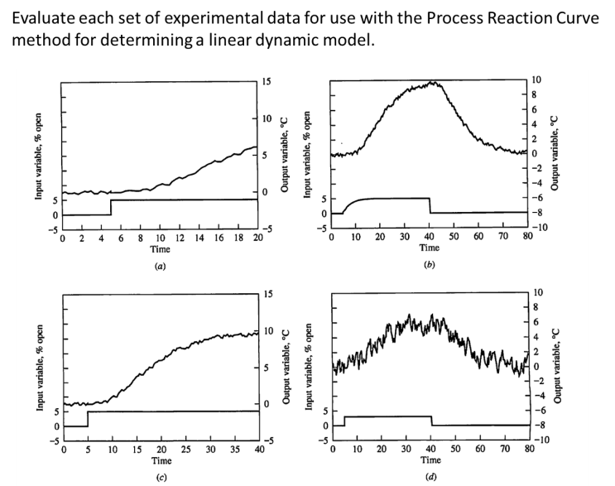
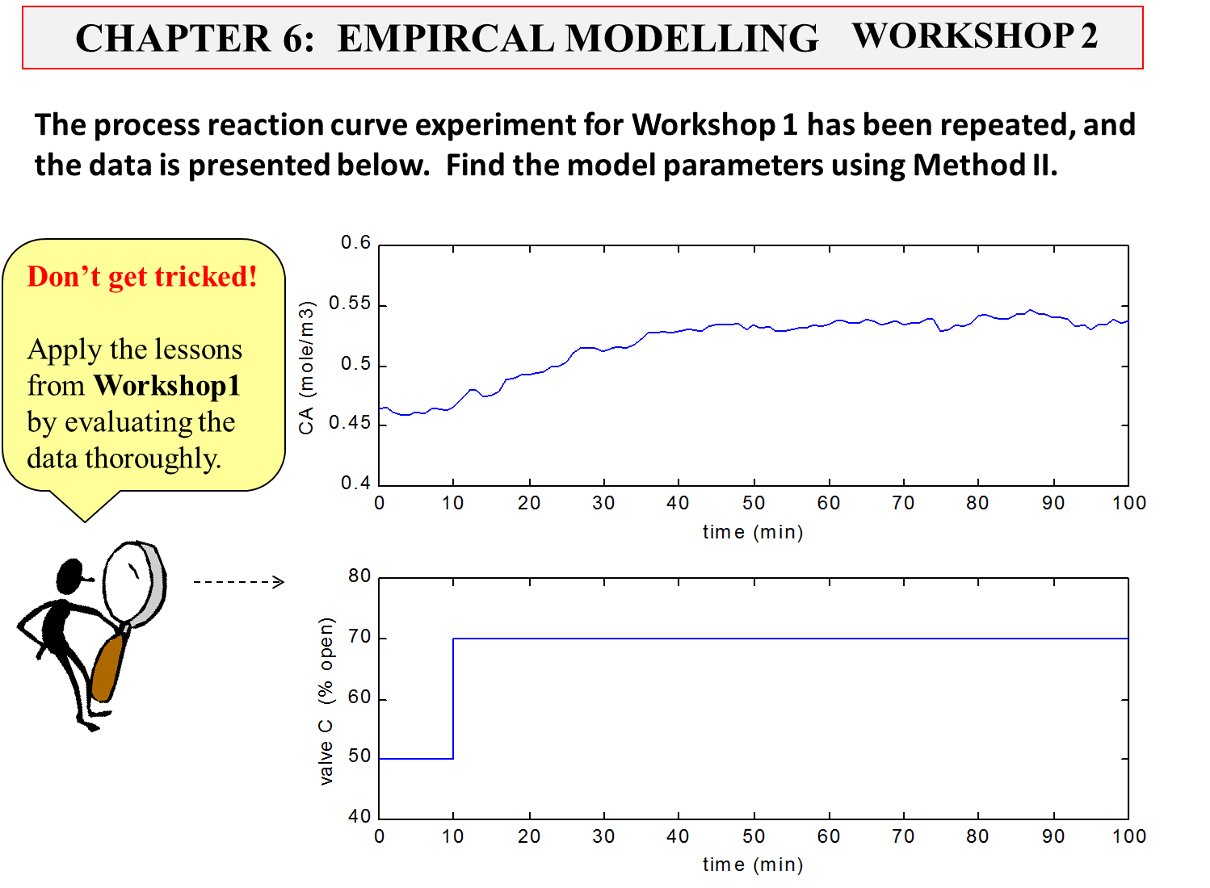
Copyright © Thomas Marlin 2016
