Slide 1
Slide 2
Slide 3
Slide 4
Slide 5 | 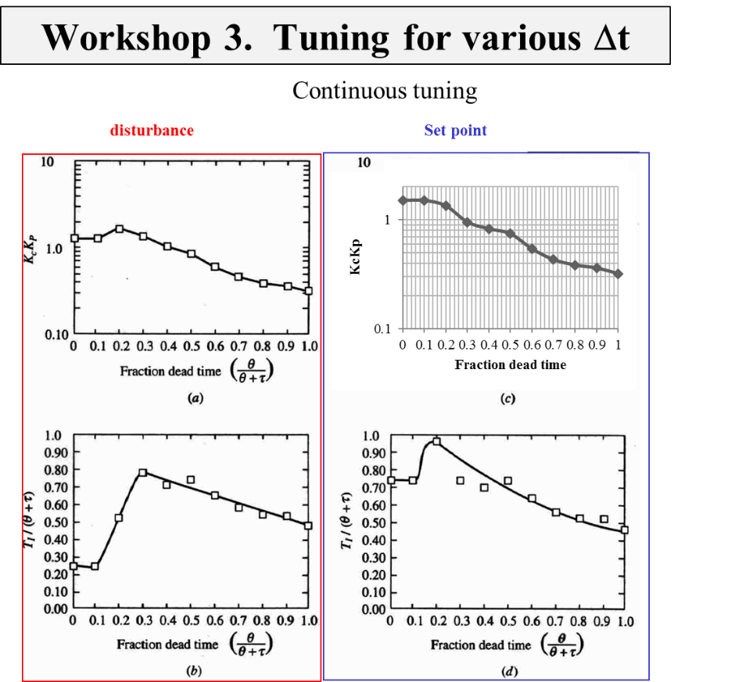
Slide 6 | 